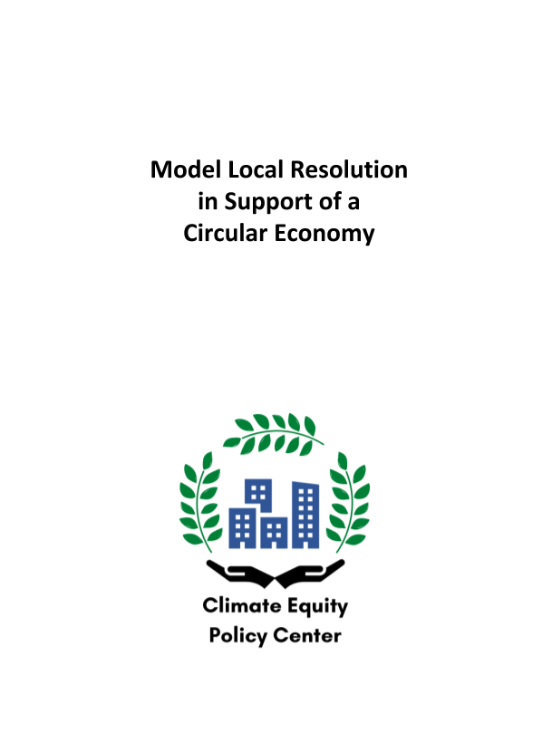
Model Local Resolution
in Support of a Circular Economy

Introduction
A circular economy is an economic system that reduces resource use and waste by designing systems so that products and services stay in use and are reused in new forms. This approach saves resources and money, supports health by protecting air quality and water quality, and lets natural systems thrive. Our current economy primarily functions in a linear way, unendingly extracting resources from nature, designing products for brief use, and then producing enormous amounts of waste and pollution. Local and state governments around the United States are joining other countries around the globe in taking steps to move toward a circular economy. As we look to renew the vigor and resiliency of our pandemic-damaged economies, there is no better time for investing in a system that is more efficient, saves money, promotes opportunity, and protects our communities from pollution and toxic contaminants.
Model Resolution
This model resolution is intended to assist local governments in initiating deliberate steps along the path towards a circular economy. Most cities and towns already engage in one or more practices that are considered circular – actions such as composting yard waste, recovering electronic waste products, banning or imposing fees on single use plastic bags, considering product lifespan in procurement decisions, and so on. This model resolution helps local jurisdictions commit to exploring and moving toward a circular economy. The resolution sets out a general commitment to a transition to a circular economy, designates a lead department or official, calls for an initial assessment of resource and waste in-flow and out-flow and for a more comprehensive emissions analysis, encourages support for and exploration of business and job creation opportunities, and provides for a report on initial activities and consideration of follow up steps and new policies after the resolution has been in place for one year.
Definitions: Circular Economy, Regenerative Economy, and Doughnut Economics
Different economic theories describe variations on how to frame the concept of an economic system that avoids waste and environmental injustice, reduces resource extraction through reuse of materials and products, and supports jobs. Different emphases may be preferred in different communities, but the policy steps described in this resolution are effective regardless of the term used. Despite their differences, these theories are generally consistent with each other and the implementation of one should bolster rather than negatively affect the others.
Circular Economy: As discussed above, the term circular economy emphasizes the circular loops that return biological materials to natural systems and retain non-biological materials for long-term use and reuse in production.
Regenerative Economy: The term regenerative economy is related but places a greater emphasis on a just and sustainable economic system that incorporates circularity, regeneration, equity, and balance.
Doughnut Economics: In the concept of doughnut economics, the inside ring of the doughnut shows the minimum humans need to survive and thrive, the outside ring depicts the limitations of the planet, and the area between these shows the area within which our economy can flourish.

The Climate Equity Policy Center developed this model resolution to assist local governments in reducing waste and pollution, improving product streams, reducing climate emissions, and transitioning to an equitable circular economy. This document is not intended to provide legal advice. For legal advice, please consult a lawyer who is licensed to practice law in your state.

A Resolution of the [Legislative Body] of [Local Jurisdiction]
in Support of a Circular Economy

Comment: A resolution is made up of whereas clauses and resolved clauses. The whereas clauses represent the findings of the jurisdiction, and are intended to convey the need and urgency for a resolution, context and considerations, legal basis, and similar background. The resolved clauses set out commitments and direct governmental actions. Generally, the format of a resolution is not used by a jurisdiction to impose binding requirements upon private individuals or businesses – for those purposes, an ordinance, law, regulation, or statute would usually be used; however, it is common in many states for local jurisdictions to use a resolution format to direct actions by the jurisdiction itself and its agents and to set forth commitments.
WHEREAS, our communities face serious and intersecting crises involving current and potential future pandemics, economic distress, climate change and environmental degradation, and social and racial inequities related to education, jobs, housing, health, and more;
WHEREAS, these crises are threatening our quality of life, our health, local economic activity, and our ability to live in a just and stable society, along with the future of life for ourselves, our children, and theirs;
WHEREAS, these challenges present an opportunity to move towards creation and support of communities that are healthy and thriving, in which our economic systems allow people at all income levels to support themselves and their families with dignity, in which low-income communities are not repositories for waste, pollution, and contaminants, but are stable and healthy zones for networks of family and community, and where our relationship with the natural world allows humans and ecosystems to thrive;
WHEREAS, an important component of addressing these challenges is moving toward a circular economy – an economy in which resource extraction and waste are reduced to a minimum, resources are reused efficiently, the value of products, materials, and resources is maintained, and natural systems are regenerated – and circular economic practices support local, national, and global health, stability, and economic prosperity;
WHEREAS, the concept of a circular economy provides a unifying framework for current and future policies and practices in the public and private sectors that enable economic recovery and success, along with environmental sustainability;
WHEREAS, governments such as those of China, Japan, and the European Union, as well as the US Chamber of Commerce Foundation and a variety of cities in the United States, have embraced the circular economy as a governing framework for industrial and economic development, in order to obtain increased economic vibrancy and efficiency with decreased environmental impact;

Comment: Many countries around the world have embraced the necessity of a circular economy and taken significant steps to move toward this outcome. Despite the fact that such efforts are in progress, their actions demonstrate that such commitments are feasible and realistic. However, it is certainly wise to omit the reference to other countries if that has the potential to decrease support for the resolution rather than increase support.
WHEREAS, a circular economy brings economic benefits for individuals, businesses, and government, by reducing costs of resources and waste disposal, generating jobs, supporting efficiency in design, creating a level playing field for responsible businesses, and decreasing externalized health and climate costs;
WHEREAS, the immense economic challenges caused by the 2020 Covid-19 pandemic require a response of active intervention at different levels of government in order to address mounting budgetary challenges for local governments and to prevent devastating increases in poverty, bankruptcies, wealth loss, and suffering for community members and local businesses;
WHEREAS, local and state governments can support and invest in rebuilding our economies to drive change in key local systems and incorporate and strengthen concepts of circularity, in order to provide for good jobs for residents, thriving local businesses, healthy communities, and sustainable and regenerative intersections between the natural and human worlds;
WHEREAS, [Local Jurisdiction] experiences the following threats from pollution, environmental degradation, and climate change: [insert relevant local climate and environmental threats, such as hurricanes, wildfires, flooding, water pollution, storms, heat events, changes in growing seasons, air pollution, pests and disease, etc.];
WHEREAS, [Local Jurisdiction] has a variety of policies and practices that already support a circular economy, including [list one or more policies or practices that support resource conservation and waste reduction, such as composting, waste diversion, or other policies];
WHEREAS, [Local Jurisdiction] wishes to identify and begin implementation of opportunities to advance the core goals of a circular economy: (1) designing products and systems to avoid any generation of waste or pollution; (2) ensuring that materials and products are reused, stay out of waste streams, and maintain their value; and (3) protecting and supporting regeneration of natural systems;

Comment: Add any additional whereas clauses that are pertinent to local or state conditions or laws.

NOW, THEREFORE, BE IT RESOLVED by the [Legislative Body] of [Local Jurisdiction] as follows:
- [Local Jurisdiction] is committed to supporting the steady transition away from current economic practices dependent upon resource extraction and waste towards circular economic practices that increase efficiency and sustainability, support local employment, and retain wealth and value in our community;
- [Local Jurisdiction] hereby designates [insert local official or department such as the city manager, department of sustainability, or waste management department] to be responsible for overseeing circular transition work as [Circular Economy Lead], to undertake the actions specified in this resolution, and to promote transparency with regard to these and related actions, assessments, and determinations;

Comment: It is often deemed beneficial to have the designated department be one that has broader authority and responsibilities within the local jurisdiction, since otherwise the scope of the circular economic analysis and considerations are more likely to be limited to matters under the authority of the relevant department. Note also that If an alternative title to Circular Economy Lead is preferred, that description may be substituted in the resolution.

- [Circular Economy Lead] shall conduct a preliminary assessment of resource, waste, and pollution in-flow and out-flow in [Local Jurisdiction], as well as whether there are neighborhoods or census tracts that experience particular exposure to waste or pollution, as a first step in identifying opportunities to reduce and eliminate these products;

- [Local Jurisdiction] commits to baseline and periodic ongoing measurements of resource use, waste generation, pollution, and carbon emissions within [Local Jurisdiction] on a consumption basis broken down by public, business, and individual sectors;

Comment: Different measurements are available to assess the generation of waste, pollution, and emissions., The internationally recognized Greenhouse Gas Protocol identifies three aspects of greenhouse gas emissions: scope 1 (direct emissions); scope 2 (emissions from purchased energy); and scope 3 (other emissions generated through outsourced or antecedent activities or in relation to the value chain). When only emissions that are directly released during the use of a product are measured, it may have the effect of obscuring the impact of manufacturing and transport factors that may generate the majority of the emissions associated with a product. While it is beneficial to consider a variety of metrics, which may reveal different opportunities to take action to reduce emissions, consumption-based measurements are key to realistically understanding and reducing impacts.

- [Circular Economy Lead] shall assess [Local Jurisdiction]’s ability to improve practices and adopt policies to advance circularity in areas such as: (1) reducing waste in city construction, procurement, and contracting; (2) food waste reduction; (3) zoning and building codes; and (4) reducing waste and pollution in water from flooding, storm runoff, and other sources;
- [Circular Economy Lead] shall assess strategies to reduce exposure to waste or pollution for [Low Jurisdiction’s] low-income neighborhoods and census tracts and those with particular exposure to waste or pollution, identifying opportunities within new circular practices to reduce such exposure, and identifying and mitigating any potential increase in such exposure;
- [Local Jurisdiction] commits to promoting circular business opportunities, especially for locally owned businesses;
- To promote such opportunities, [Circular Economy Lead] shall ensure that [Local Jurisdiction] takes steps to encourage the launching of new circular businesses, support improvements in circular business practices for existing businesses, and encourage training of workers with skills to execute green and circular jobs;
- [Circular Economy Lead] shall conduct an assessment of the job-creation potential for local residents of investment in and transition to a circular economy, with a particular focus on quality of jobs and on demographic groups with higher underemployment or unemployment rates; the assessment shall include exploration of pilot programs and effects of governmental investments and incentives;
- [Circular Economy Lead] shall identify one or more policies to propose for adoption [within one year] of the passage of this resolution, in order to advance a circular economy while supporting workforce development and increased community equity;
- Within one year of the date of adoption of this resolution, [the official or department designated above] shall present a report to the [Legislative Body] summarizing the activities conducted to date in the implementation of this resolution, describing the results of the assessments of resource, pollution, and waste in-flow and out-flow and the opportunities to reduce particular exposure to waste or pollution, and setting forth recommended actions; upon receipt of the report the [Legislative Body] shall hold a hearing to determine further implementation steps, including consideration of recommended policies.
PASSED AND ADOPTED by the [Legislative Body] of [Local Jurisdiction] on [Date].

This resolution and the accompanying memorandum were prepared with support from the implementation project of Legal Pathways to Deep Decarbonization (Michael B. Gerrard and John C. Dernbach, eds. Environmental Law Institute [2019]) (LPDD), https://lpdd.org. Also contributing to the resources were Scott W. Badenoch, Jr., Visiting Attorney, Environmental Law Institute; Moira O'Neill, Senior Research Fellow, Center for Law, Energy, and the Environment, BerkeleyLaw; Noble Smith ‘22, Howard University School of Law; Shruthi Srivatsan ’22, Swarthmore College; Tenaya McCoy ’21, Brown University.
Ellen MacArthur Foundation, “The Circular Economy in Detail,” 2019, https://www.ellenmacarthurfoundation.org/explore/the-circular-economy-in-detail.
World Bank Group, “China Circular Economy Promotion Law,” 2008, https://ppp.worldbank.org/public-private-partnership/library/china-circular-economy-promotion-law#:~:text=The%20Law%20is%20formulated%20for,environment%20and%20realizing%20sustained%20development; Ministry of the Environment, Government of Japan, “Creation of a Regional Circular and Ecological Sphere (Regional CES) to Address Local Challenges,” Annual Report on the Environment in Japan 2018, 2018, https://www.env.go.jp/en/wpaper/2018/pdf/04.pdf; European Commission, “A New Circular Economy Action Plan for a Cleaner and More Competitive Europe,” 2020, https://ec.europa.eu/environment/circular-economy/.
U.S. Chamber of Commerce Foundation, “Sustainability and Circular Economy Summit Series,” https://www.uschamberfoundation.org/event/sustainability-summit-series-circularity-sustainable-and-secure-future; see also U.S. Chamber of Commerce Foundation, “Creating a Circular Economy in the Great Lakes Region,” 2020, https://www.uschamberfoundation.org/reports/creating-circular-economy-great-lakes-region.
Breen, Charlotte and Vangsbo, Peter, “Municipality-led Circular Economy Case Studies,” C40 Cities, 2018, https://www.c40.org/researches/municipality-led-circular-economy.
Ellen MacArthur Foundation, “Completing the Picture: How the Circular Economy Tackles Climate Change,” 2019, www.ellenmacarthurfoundation.org/publications/completing-the-picture-climate-change.
Ellen MacArthur Foundation, “Completing the Picture: How the Circular Economy Tackles Climate Change,” 2019, www.ellenmacarthurfoundation.org/publications/completing-the-picture-climate-change; World Economic Forum, “Towards the Circular Economy: Accelerating the Scale-up across Global Supply Chains,” 2014, http://www3.weforum.org/docs/WEF_ENV_TowardsCircularEconomy_Report_2014.pdf.
Heybroek, Natalja, “Data-driven tools to accelerate and scaleup solutions for circular cities,” Metabolic, 6/23/20, https://www.metabolic.nl/news/data-driven-tools-for-circular-cities/.
Carbon Trust, “Briefing: What are Scope 3 emissions?,” https://www.carbontrust.com/resources/briefing-what-are-scope-3-emissions#.
Greenhouse Gas Protocol, “Calculation Tools: Frequently Asked Questions,” https://ghgprotocol.org/calculationg-tools-faq.
C40 Cities, “Consumption -Based GHG Emissions of C40 Cities,” 2018, https://www.c40.org/researches/consumption-based-emissions.

